Case Study: Kubernetes-Based Robotics Orchestration Platform: A Scalable, Secure, and Modular Robot Control System

*Author: Tatenda Manyepa*

Table of Contents

1

Introduction 4

Problem Statement and Current Challenges 5

Proposed Solution 6

Architecture Diagram 7

High-Level Architecture Diagram 7

8

Detailed Infrastructure Diagram 9

Key Architectural Components 10

Architecture Flow 10

Terraform Infrastructure Overview 12

Terraform-Managed Infrastructure 12

Scalability, Flexibility, and Reusability 13

Benefits & Expected Impact 13

Cost Analysis & Trade-Offs 14

Challenges & Considerations 14

Future Enhancements 14

Conclusion 14

Next Steps 15

# Introduction

Robotic systems are increasingly being integrated into industries such as e-commerce, healthcare, agriculture, and manufacturing to enhance efficiency, automation, and productivity. However, most existing **third-party robot control systems** present significant challenges, including:

* **Slowness and Inefficiency** – Legacy monolithic architectures lead to performance bottlenecks.
* **Lack of Flexibility** – Hard-coded configurations limit adaptability to different environments.
* **Poor Integration Capabilities** – Difficulty in integrating with external APIs, cloud services, and other enterprise systems.
* **Scalability Issues** – Traditional control systems are not designed to scale efficiently across multiple locations or robotic fleets.
* **Security and Monitoring Gaps** – Inadequate access control, secrets management, and observability.
* **Incompatibility Across Robot Vendors** – Many control systems are built for specific robot brands and management systems, making cross-platform integration and multi-vendor support difficult.

To address these challenges, this proposal outlines a **Kubernetes-based Robotics Orchestration Platform**, designed as a **cloud-native, modular, and scalable** solution. This architecture leverages **Kubernetes for orchestration, Terraform for automated infrastructure provisioning, and event-driven communication (Kafka/MQTT)** to enable real-time, scalable, and secure robotic control. The solution is designed to be **industry-agnostic**, making it adaptable for multiple robotic applications across various sectors.

# Problem Statement and Current Challenges

Most third-party robot control systems suffer from fundamental limitations that hinder efficiency, scalability, and adaptability. The key challenges include:

|  |  |  |
| --- | --- | --- |
| Issue | Cause | Proposed Solution with Kubernetes and Terraform |
| **Slowness of the system** | Monolithic architecture with inefficient resource allocation and no auto-scaling when workload increases. | **Kubernetes-based auto-scaling** dynamically adjusts resources and the m**icroservices approach** improves efficiency. |
| **Data to/from robots not updating promptly** | High-latency communication between robots and control system and poor event-driven architecture. | **Event-driven design using Kafka/MQTT** ensures real-time updates and e**dge computing with K3s** reduces latency. |
| **Cannot be repurposed for other industries** | Hard-coded logic specific to warehouse robots and no modularisation | **Modular microservices architecture** allows reusability and c**ontainerised workloads** run across different environments. |
| Lacks Integration Flexibility | No API or outdated integrations - Vendor lock-in. | **REST/gRPC APIs with Kubernetes services** enable interoperability. **Cloud-agnostic with Terraform**, deployable on AWS, Azure, GCP, or on-prem. |
| **Difficult to scale across multiple locations** | Single data centre, no cloud-native design - No horizontal scaling | **Multi-cloud & hybrid Kubernetes clusters** enable easy scaling. **Geo-distributed workloads** with Kubernetes federations. |
| **Lack of observability & monitoring** | No centralised logs or metrics and debugging failures is time-consuming | **Prometheus, Grafana, and CloudWatch** for real-time monitoring. **Automated logging & alerting** with Fluentd and OpenTelemetry. |
| **Security risks & hard-coded credentials** | Credentials stored in the app or database. No centralised secrets management | **AWS Secrets Manager / HashiCorp Vault** for secure secrets management. **Role-based access control (RBAC) in Kubernetes** for security. |

Addressing these challenges requires a modern, cloud-native architecture that can support scalability, flexibility, real-time communication, and robust security. The following sections outline the proposed solution leveraging Kubernetes, Terraform, and event-driven microservices to overcome these limitations.

# Proposed Solution

This solution introduces a **Kubernetes-based Robotics Orchestration Platform** that provides scalable, secure, and modular robotic control. It leverages:

* **Kubernetes for workload orchestration**, allowing robots to operate independently yet interact efficiently.
* **Terraform for infrastructure automation**, ensuring a repeatable and consistent deployment process.
* **Event-driven communication (Kafka/MQTT)** for low-latency, real-time updates between robots, control systems, and external services.
* **Cloud-agnostic deployment**, allowing integration across **AWS, Azure, GCP,** and on-premise environments.

The architecture is designed to be **vendor-neutral**, supporting multiple robot manufacturers and various versions of warehouse management systems (WMS). By containerising robot control logic, the system ensures flexibility, enabling seamless adaptation across industries such as warehousing, healthcare, and manufacturing.

# Architecture Diagram

To provide a clear understanding of the **Kubernetes-Based Robotics Orchestration Platform**, this section will include two diagrams.

# High-Level Architecture Diagram

**Driven Communication (Kafka/MQTT), Monitoring, and Scalability Services** This diagram provides an **overview of the key components**, including **API Gateway, Kubernetes Cluster, Event**

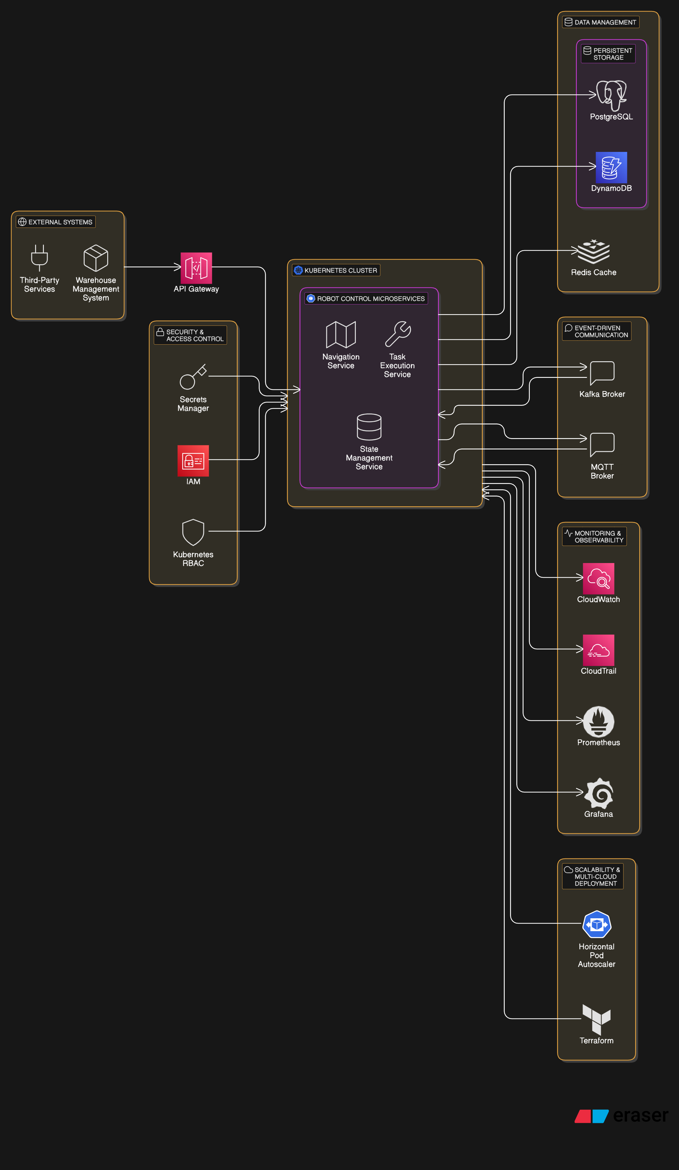

# Detailed Infrastructure Diagram

**The technical breakdown includes networking details (VPC, subnets), security components (IAM, RBAC, Secrets Manager), and database storage layers (Redis, DynamoDB, PostgreSQL)**. It provides **a detailed view of how services can be deployed within cloud and hybrid environments.**

# Key Architectural Components

1. **Networking & Security**

* **VPC & Subnets**: Isolated **private/public subnets** for security.
* **IAM & RBAC**: Secure role-based access using **AWS IAM + Kubernetes RBAC**.
* **Secrets Management**: **AWS Secrets Manager / HashiCorp Vault** for credentials.
* **Ingress & Load Balancing**: Secure traffic management using **Nginx Ingress / AWS ALB**.

1. **Compute & Orchestration**

* **Kubernetes Cluster (EKS, AKS, GKE, or K3s for Edge)**: Handles robotic workloads dynamically.
* **Auto-Scaling**: **Kubernetes HPA (Horizontal Pod Autoscaler)** ensures robots are scaled up/down automatically.
* **Multi-Cloud & On-Prem Support**: **Terraform provisions clusters** on AWS, Azure, GCP, or hybrid environments.

1. **Message-Based Robot Communication**

* **MQTT / Kafka Event Streaming**: Ensures real-time communication with robots.
* **Redis / DynamoDB for Shared State**: Fast, scalable storage for robot states.

1. **Data & Monitoring**

* **CloudWatch / Prometheus / Grafana**: **Real-time monitoring** of robot operations.
* **CloudTrail / Kubernetes Audit Logs**: **Full auditability** of API calls and deployments.

## Architecture Flow

Understanding how the various components interact within the **Kubernetes-Based Robotics Orchestration Platform** is essential to grasping the system’s efficiency, security, and scalability. The architecture follows a structured flow from external requests to orchestration, communication, and monitoring.

1. **External Requests & API Gateway**

* Third-party services and warehouse management systems communicate with the platform through the **API Gateway**.
* The API Gateway routes traffic securely to appropriate services within the **Kubernetes Cluster**.

1. **Networking & Security**

* The entire system is hosted within a **Virtual Private Cloud (VPC)**, with **public and private subnets** isolating critical workloads.
* **IAM & RBAC** enforce access control, ensuring that only authorised entities interact with services.
* **Ingress Controllers and Load Balancers** handle external traffic securely and distribute workloads efficiently.

1. **Compute & Orchestration**

* The **Kubernetes Cluster (EKS, AKS, GKE, or K3s for Edge)** runs containerised **robot control microservices**.
* These microservices dynamically scale using **Horizontal Pod Autoscaler (HPA)** based on demand.
* **Terraform automates the provisioning** of Kubernetes clusters across AWS, Azure, GCP, or hybrid environments, ensuring flexible multi-cloud support.

1. **Message-Based Robot Communication**

* Robots interact with the control system using **MQTT/Kafka brokers** for event-driven messaging.
* **Redis or DynamoDB stores real-time robot states**, enabling quick lookups and state synchronisation across services.

1. **Data & Monitoring**

* **CloudWatch, Prometheus, and Grafana** provide real-time monitoring of robot performance and system health.
* **CloudTrail and Kubernetes Audit Logs** ensure all actions are recorded, providing full auditability and security oversight.

1. **Scalability & Optimisation**

* **Terraform manages infrastructure scaling**, enabling easy replication of environments in multi-cloud and hybrid setups.
* **HPA and Kubernetes Federation** ensure that robotic workloads can scale across distributed regions.

1. **Security & Secrets Management**

* **AWS Secrets Manager or HashiCorp Vault** securely manages credentials.
* **Role-Based Access Control (RBAC)** ensures least-privilege access to Kubernetes resources

# Terraform Infrastructure Overview

To facilitate the provisioning of the **Kubernetes-Based Robotics Orchestration Platform**, **Terraform** is used to automate the deployment of cloud resources efficiently across AWS, Azure, and GCP. This section outlines the **key infrastructure components managed by Terraform** along with best practices for configuration.

## Terraform-Managed Infrastructure

1. **Networking & Security**

* Provision a **VPC with public and private subnets** to isolate workloads.
* Configure **security groups, IAM roles, and Kubernetes RBAC policies**.
* Set up **AWS Secrets Manager or HashiCorp Vault** for credentials management.

1. **Kubernetes Cluster Provisioning**

* Deploy **Amazon EKS, Azure AKS, or Google GKE clusters**.
* Configure **node groups with autoscaling policies**.
* Implement **Kubernetes Role-Based Access Control (RBAC)** for security.

1. **Infrastructure as Code Best Practices**

* **Remote State Management**: Store Terraform state in **S3 with DynamoDB locking**.
* **Modularisation**: Use Terraform modules to separate concerns (networking, compute, IAM, security).
* **Multi-Cloud Flexibility**: Define Terraform configurations that work across **AWS, Azure, and GCP**.

1. **Example Terraform Snippet: EKS Cluster Creation**

This Terraform snippet provisions an **EKS cluster** with **autoscaling worker nodes**, ensuring flexibility and resilience for robotic workloads.

1. **Additional Terraform Considerations**

* **Logging & Monitoring:** Enable **CloudWatch, Prometheus, and Grafana** integration.
* **Database & Storage:** Provision **DynamoDB, Redis, or PostgreSQL** for robot state persistence.
* **CI/CD Integration:** Implement Terraform pipelines using **GitHub Actions, AWS CodePipeline, or Jenkins**.

By leveraging Terraform, organisations can efficiently provision, manage, and scale the **robotics orchestration platform** while maintaining **consistency, security, and automation**.

# Scalability, Flexibility, and Reusability

1. **Industry-Agnostic Design**

* Adaptable to **warehouse logistics, healthcare robotics, smart farming, and manufacturing**.

1. **Modular Microservices Approach**

* Each robot function (**navigation, path optimisation, object detection**) is deployed as a **separate Kubernetes service**, allowing independent scaling and flexibility.

1. **Multi-Region Deployment**

* **Terraform automates the provisioning of geo-distributed Kubernetes clusters**, ensuring redundancy, fault tolerance, and high availability.

# Benefits & Expected Impact

1. Reduced latency and faster robot response times.
2. Automated scalability based on robot demand.
3. Easier reusability across industries.
4. Better security posture with IAM, RBAC, and encryption.
5. Improved observability with CloudWatch, Prometheus, and ELK.

# Cost Analysis & Trade-Offs

1. **Infrastructure Costs**: Running Kubernetes clusters and Terraform-managed cloud environments incurs costs, but **auto-scaling and multi-cloud optimisations help reduce waste**.
2. **Complexity vs. Maintainability**: Kubernetes requires expertise, but **once automated, it significantly improves system reliability**.
3. **Vendor Lock-in**: Terraform allows multi-cloud support, but **some AWS/Azure/GCP-specific services may limit full portability**.
4. **Latency vs. Compute Cost**: Using **Edge computing (K3s) reduces latency but may require additional infrastructure investment**.

# Challenges & Considerations

1. **Networking Complexity**: Kubernetes networking is more complex than traditional monolithic applications, requiring careful configuration of service meshes, network policies, and ingress controllers.
2. **Learning Curve**: Requires expertise in **Terraform, Kubernetes, and event-driven architecture**, making adoption challenging for teams without prior experience.
3. **Cost Management**: Running **Kubernetes clusters continuously** incurs cloud costs, but **auto-scaling and efficient resource allocation** help minimise expenses.

# Future Enhancements

1. **AI & Machine Learning Integration**: Use **AI-driven models** to optimise **robot task scheduling, predictive maintenance, and real-time anomaly detection**.
2. **Hybrid Deployment Model**: Implement **Kubernetes at the Edge (K3s) and cloud** to enhance **low-latency real-time control** for autonomous robots.
3. **Serverless Additions**: Utilise **AWS Lambda** or **Azure Functions** for **event-driven robotic task execution**, reducing operational overhead and increasing efficiency.

# Conclusion

This proposal provides a **modern, scalable, and secure** alternative to legacy robot control systems. By leveraging **Kubernetes, Terraform, and event-driven microservices**, the proposed solution ensures **efficiency, flexibility, and adaptability** across multiple industries and robotic deployments.

# Next Steps

1. **Validate the design with Proof of Concept (PoC) simulations** to test system feasibility.
2. **Develop a Minimum Viable Prototype (MVP)** using Kubernetes on **AWS, GCP, or Azure**.
3. **Explore Edge Computing with Lightweight Kubernetes (K3s)** to optimise real-time processing and reduce latency.